Spectra

Business Meeting 8/23/22

horizontal line

**23 August 2022 / 12-2P PST**

# Zoom Info

Zoom Recording

# ATTENDEES

In-person (Zoom): Juliette Bruce, Keri Sather-Wagstaff, Lily Khadjavi, Joseph Nakao, Andrew Bernoff, Alex Hoover, Chris Goff, David Crombeque, Mike Hill, Ron Buckmire

Absent:

AGENDA

## **Last Meeting Follow-up**

1. Fundraising Updates: We received $10,000 from Andrew Sutherland, $1,000 from John Voight, $5,000 from Don Goldberg, $100 from Ravi Vakil, and ~$1,600 from GoFundMe: Total ~$17,700. With the promised matching: $22,700.
2. Lavender Lecture: Melody Chan respectfully declined, Luis Leyva accepted and then afterwards requested additional funding. He is currently asking for an additional $500, so a total of $1000.
   1. Agreement to provide additional support.
   2. Suggests need to create a budget.
3. Launching Membership: Juliette B. will send an email out about membership policies for the year. How do we get departments to join?

## **New Business**

* **2022 Election (Mike H. & Juliette B.):** The call for nominations will be sent out by Mike H. on August 1st. All of the committee chairperson positions as well as the at large member positions will be up for election. A brief overview of the timeline for the election is below:

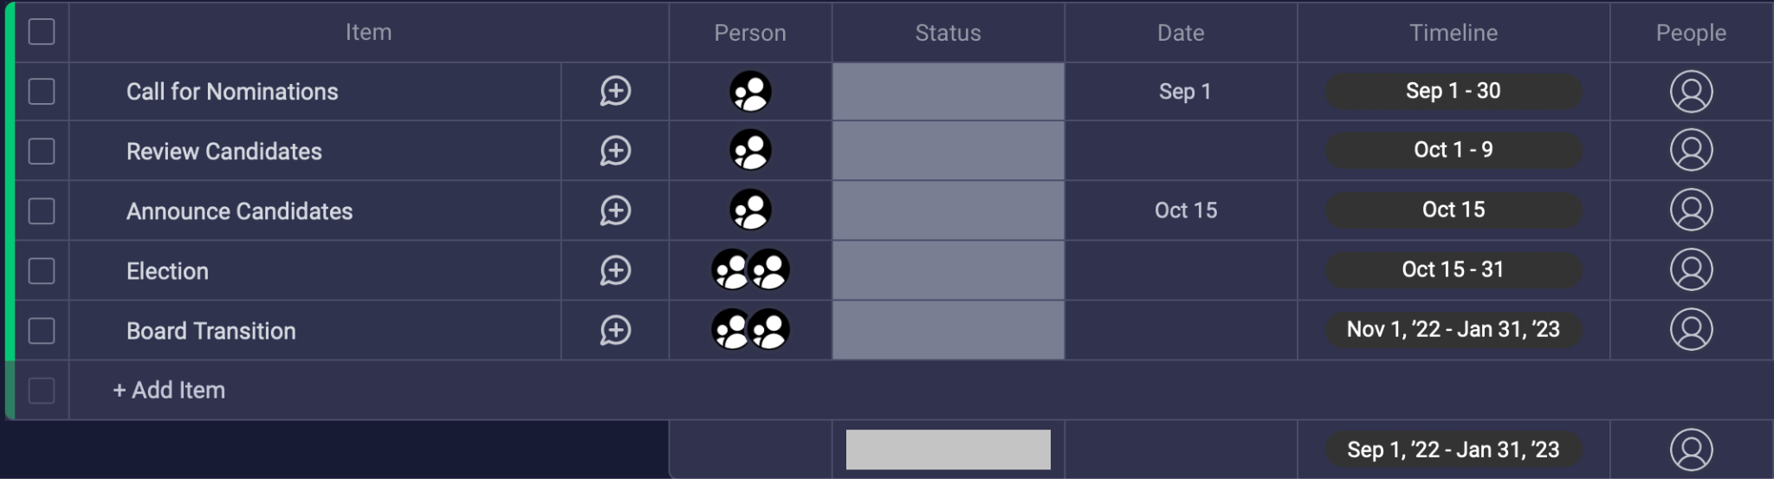

* **Sponsoring Event of UofK (Chris G.):** Funding request from University of Kentucky (Ben Jany and Kathryn Hechtel) for $500-$1000 in support of a math conference they are putting on for LGBTQ+ grad students and postdocs in the spring.
* **Non-Profit Status (Juliette B.):** This is something we’ve discussed doing, and I think this is something we should decide whether or not to begin pursuing this year.
* Projects for the Semester (Juliette B.):
  + Spectra Research Conference
  + New Website
  + Newsletters
* Spectra at [SIAM CSE23](https://www.siam.org/conferences/cm/conference/cse23) in Amsterdam? **We will try to do something there. (Hoover and Buckmire will be part of a MS)**
* Spectra Participation/Position on Conferences in “bad” place (i.e. AMS Joint Subcommittee on Holding Meetings in Localities with Discriminatory Practices or Laws)
* JMM23 reception in Boston (Joseph N.):
  + How much money?
  + Forming a sub-committee
  + Removing the mystery names from the sign-up spreadsheet? ([link here](https://docs.google.com/spreadsheets/d/15QytgvfKs0QkO985cFZv4_omg7sYQsSIq8_eZVp7wzA/edit#gid=1737691125))
  + (A) daytime reception at other locations not necessarily surrounded by alcohol.
  + **Brainstorming/meeting session at JMM23 (**[cgoff@pacific.edu](mailto:cgoff@pacific.edu)**)**

# ACTION ITEMS

# UPCOMING & PAST EVENTS

# DREAM & LARGE SCALE GOALS